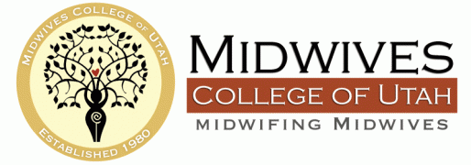

Hello!
As Faculty Director and Professional Development Coordinator for MCU, it has been my job to identify resources to meet our school’s need for copyright training. MEAC’s Standards for Programmatic Accreditation, Benchmark B-Orientation and Professional Development, states: “Faculty receive training and materials related to copyright law, the doctrine of fair use, plagiarism, and other relevant legal and ethical concepts.” Those efforts, of course, must be documented and produced upon MEAC review.
As well, in August of 2008, Congress amended the Higher Education Act (HEA) to require all colleges and universities that receive student financial aid funding from the federal government to provide notice to college students regarding policies about copyright compliance and appropriate digital file sharing. It is this training, in fact, that provides you with copyright Fair Use privileges and protection!
So now you have a student who wants to include Beatles song in a multimedia presentation about the 1970s midwifery movement, an instructor who wants to include a Carl Sandberg poem in her course on midwifery history, and a third who wants to use photographs of a breech birth she attended in her handout assignment. How do you navigate these decisions and provide competent direction?
The good news is that copyright law is intended to benefit educators and students!
We have a three-fold mandate: train faculty and administration; create policy and procedure to support the copyright compliance, and teach students how to be copyright compliant both in the classroom and in their own private practices.
After some looking around, we decided to develop our own Copyright for Midwifery Educators module. This 90-minute course is specifically designed to meet the needs of our small midwifery schools and the specific needs of our midwifery students. Copyright law, much like HIPAA, can be quite complex; this presentation culls down the overload of information and addresses classroom, faculty, and administrative needs. The course objectives can be summed up as follows:
- Understand the meaning and legal history of Copyright law
- Understand the concepts of Intellectual Property, Fair Use, Public Domain, Commercial Purpose, Fair Use Act, TEACH Act, and Creative Commons
- Understand Copyright Fair Use as it applies differently to institutions, educators, and students
- Identify permission routes, such as Copyright Clearing Center
- Understand how to create and model Copyright-compliance in the classroom
- Identify potential Copyright infringements
- Identify Copyright Compliance Best Practices

The module will also provide your school with helpful handouts, such as a Materials Use Chart, a Guideline & Decision Tree to simplify teacher and student work, a compilation of sample copyright statements for various media and uses, and a curated list of helpful websites to help you create your own support plan. The Implementation Checklist provides you with a framework to begin generating changes in your administration and classrooms.

I feel quite confident that the work we’ve put into creating this Copyright for Educators module will meet your school’s needs—it’s easy to understand, it demystifies the copyright fog, it is scaled to meet the needs of our smaller schools, and it specifically addresses the needs of midwifery in the classroom and in private practice. The live course also offers the opportunity for your employees to ask questions and seek clarifications.

Jana Studelska, Faculty Director & Professional Development Coordinator
jana.studelska@midwifery.edu
866.680.2756 ext. 812

